


A Mini Project Report
On
Stock price visualizer and predictor
By

Shreyash Zope | 4301066
Rohit Sawant | 4301056
Onkar Avakale | 4301003
Amey Mojar  Rohan Chavan | 4301037  4301078

Under the guidance of
Prof. Gayathri Ganesan

DEPARTMENT OF INFORMATIO N TECHNOLOGY

Sinhgad Institute of Technology and Science, Narhe, Pune.

Savitribai Phule Pune University [Academic Year: 2025-2026]


Department of Information Technology,
Sinhgad Institute of Technology and Science, Narhe, Pune.

Certificate

This is to certify that final project entitled PMark-Attendance Management App was successfully carried out by following students from Fourth Year of Information Technology at Sinhgad Institute of Technology and Science, Narhe in the partial fulfilment for the degree in Bachelor of Engineering.

Shreyash Zope 4301066

Rohit Sawant | 4301056
Onkar Avakale | 4301003
Amey Mojar  Rohan Chavan | 4301037  4301078

Prof. Gayathri Ganesan | Prof. T.D. Khadtare | Dr.S.D.Markande
Guide | Head of Department | Principal

Acknowledgement

I take this opportunity to thank my internal guide Prof. Priti Yadav, for giving me guidance and support throughout the Mini Project. Her valuable guidelines and suggestions were very helpful.

I wish to express my thanks to Prof.T.D. Khadtare, Head of InformationTechnology, Sinhgad Institute of Technology and Science, Narhe for giving me all the helpand important suggestions all over the Mini Project Work. I thank all the teaching and non- teaching staff members, for their indispensable support and priceless suggestions.

I also thank my friends and family for their help in collecting data without which this Mini Project report not have been Completed. At the end, my special thanks to Dr.S.D.Markande, Sinhgad Institute of Technology and Science, Narhe for providing ambience in the college, which motivate you.

Abstract

The project Stock Analysis and Prediction using Machine Learning aims to develop an intelligent system that analyzes historical stock data and predicts short-term market movement with the help of data-driven algorithms. The system collects two years of real-time stock data using the Yahoo Finance API (yfinance) in Python. This raw data undergoes feature engineering, where financial indicators such as Price Change, 5-day Moving Average, and 10-day Moving Average are derived from standard attributes like Open, High, Low, and Close values.

After preprocessing, the dataset is divided into training, testing, and validation subsets. A Random Forest Classifier, implemented via Scikit-Learn, is trained on the historical data to learn patterns that influence market trends. The model’s performance is evaluated based on its testing accuracy and then validated using the latest day’s stock data to verify real-world prediction capability.

The backend is implemented using Node.js and Express.js, which serve as the communication layer between the Python machine-learning module and the frontend interface. The frontend (built using HTML, CSS, and JavaScript) displays the analysis results, including predictions and accuracy.

This integration of data collection, feature enhancement, machine learning, and web deployment provides users with a lightweight yet effective tool to visualize market trends and predict stock price direction. The project demonstrates how combining Python-based data science with web technologies can create a practical and interactive financial analysis platform.

Index

Content Page No.

- Introduction
  - Motivation 1
  - Relevance and Scope 2
  - Problem Statement and Objectives 2
- Hardware and Software Requirements 3
- Foundational Knowledge 4
- Work Flow 6
- Result 8
- Summary 14

Figure Index

Sr. No. | Figure Name | Page
1. | System Architecture of Stock Analysis and Prediction | 8
2. | Workflow Diagram of the Proposed System | 9
3. | Data Flow from Yahoo Finance API to Python ML Model | 9
4. | Feature Engineering Process (Price Change, SMA-5, SMA-10 | 10
5. | Random Forest Classifier – Conceptual Representation | 10
6. | Train–Test–Validation Data Split Structure | 11
7. | Integration of Node.js Server with Python ML Script | 11
8. | Frontend–Backend Communication Flow | 12
9. | Sample Graph of Stock Price Movement (2-Year Data) | 12
10. | Model Prediction Output vs Actual Market Movement | 13
11. | Accuracy Chart of Model on Test Data | 13

CHAPTER 1

Introduction

Motivation

The stock market is one of the most dynamic and unpredictable domains in the world of finance. Every second, billions of dollars are traded, and stock prices fluctuate due to a combination of factors such as investor sentiment, company performance, global events, and macroeconomic indicators. Traditionally, traders and investors have relied on technical charts, human intuition, and experience to make buying or selling decisions. However, as the volume of financial data has grown exponentially, manual analysis has become increasingly inefficient, time-consuming, and prone to human bias.

This challenge creates a strong motivation to build automated, data-driven systems that can analyze large datasets, identify hidden patterns, and predict future market trends with improved accuracy. The emergence of machine learning and artificial intelligence offers a promising solution to this problem. Machine learning models, such as the Random Forest Classifier, can learn complex relationships from past stock data and generalize these patterns to predict future price movements.

Another motivation for developing this project is to bridge the gap between academic research and real-world financial applications. Most existing stock prediction systems are either proprietary or too complex for beginners to understand. By building an open, accessible, and modular system using Python, Scikit-Learn, and Yahoo Finance API, this project provides a practical framework that can be easily replicated, improved, and extended by other researchers and students.

Moreover, the project promotes the idea of integrating machine learning with web technologies, making it possible to visualize predictions and analytics through a user-friendly web interface built with Node.js and Express.js. This integration enhances usability and allows real-time access to financial predictions.

Ultimately, the motivation behind this project lies in using technology to make intelligent financial forecasting more efficient, transparent, and accessible. By automating data analysis and prediction, the project empowers users to make better-informed investment decisions while gaining a deeper understanding .

Relevance and Scope

The relevance of this project lies in its ability to combine machine learning, financial analytics, and web-based technologies to create an intelligent system capable of predicting stock market movements. In an era where data is the most valuable resource, financial institutions, investors, and researchers increasingly depend on predictive models to make informed decisions. This project leverages real-time and historical stock data to generate meaningful insights that can assist in short-term trading strategies and trend identification.

The project’s scope extends across several domains. It includes data acquisition through the Yahoo Finance API, feature engineering to create derived indicators such as Price Change and Moving Averages, and model development using the Random Forest Classifier from Scikit-Learn. Furthermore, it integrates a Node.js and Express.js backend that acts as a bridge between the machine learning model and the user interface, allowing seamless real-time prediction access through a web browser.

By incorporating automation, scalability, and real-time processing, the project demonstrates how artificial intelligence can be practically applied in financial forecasting. Its modular architecture ensures that future enhancements—such as the use of deep learning models (LSTM, GRU) or sentiment analysis—can easily be integrated, making it a relevant and expandable framework for modern financial analytics.

Problem Statement and Objectives

The stock market is highly volatile and influenced by numerous unpredictable factors, making it difficult for investors to forecast short-term price movements accurately. Traditional analytical methods often fail to capture complex patterns within large financial datasets. Therefore, there is a need for an automated, data-driven system capable of analyzing historical stock data and predicting future price directions with reasonable accuracy.
Objectives:
1.To collect two years of historical stock data using the Yahoo Finance API.
2.To perform feature engineering by creating new indicators such as Price Change, SMA-5, and SMA-1.
3.To train and evaluate a Random Forest Classifier for predicting stock price movement.
4.To validate predictions using the latest day’s data.
5.To integrate results into a web-based interface for real-time visualization.

CHAPTER 2

Hardware and Software Requirement

  - Hardware Required

1.Intel i5 or above.
2.Minimum 8 GB.
3.At least 500 MB free disk space.
4. Internet Required for live data fetching (Yahoo Finance API).

  - Software Required

1.Windows / Linux / macOS.
2.Python, JavaScript.
3.pandas, yfinance, scikit-learn, gspread (optional).
4.Node.js with Express.js.
5.HTML, CSS, JavaScript.
6.IDEs VS Code / PyCharm / Jupyter Notebook.
7.Git/GitHub.

CHAPTER 3

Foundational Knowledge

Technologies and Frameworks utilized:

The project employs a combination of machine learning, data analytics, and web technologies to achieve accurate stock market predictions and efficient user interaction. Each technology plays a vital role in ensuring smooth data processing, model performance, and real-time visualization.

1. Programming Languages
- Python: Used for data collection, preprocessing, feature engineering, and implementing the machine learning model.
- JavaScript: Used in the backend and frontend for server operations and user interface development.

2. Machine Learning and Data Libraries
- Pandas: For data manipulation and analysis of stock datasets.
- NumPy: For handling numerical computations and arrays.
- Scikit-Learn: To build and train the Random Forest Classifier model.
- yfinance: For fetching real-time and historical stock market data from Yahoo Finance.

3. Backend Technologies
- Node.js: Provides a runtime environment to execute JavaScript on the server side.
- Express.js: A lightweight framework for building RESTful APIs and managing server-client communication.
- Dotenv & CORS: Used for environment configuration and secure cross-origin data handling.

4. Frontend Technologies
- HTML, CSS, and JavaScript: Used to design a responsive user interface displaying stock data, model accuracy, and predictions.

5. Tools and Platforms
- GitHub: For version control and collaboration.
- VS Code / PyCharm: As integrated development environments.

CHAPTER 4

Work Flow

The workflow of the project follows a systematic sequence of data acquisition, preprocessing, model
training, validation, and result visualization. Each stage plays a crucial role in ensuring that the
stock prediction process is accurate, automated, and interpretable.

Step 1: Data Collection
- The process begins by fetching two years of historical stock data using the Yahoo Finance API (yfinance) library in Python.
- The collected data includes essential market parameters such as Open, High, Low, Close, and Volume.
- If live data retrieval fails, local files like stock_data.csv or history.xls are used as backups.
- This data is stored in a structured format using pandas DataFrames for easy manipulation and analysis.

Step 2: Feature Engineering
- Once the raw data is collected, new features are created to enhance model accuracy.
- Derived attributes include:
- Price Change: Difference between the closing prices of consecutive days.
- SMA-5 (Simple Moving Average - 5 Days): Average of the last five closing prices.
- SMA-10 (Simple Moving Average - 10 Days): Average of the last ten closing prices.
- A Target variable is generated, where 1 indicates the price increased (Up) and 0 indicates a decrease (Down).
- Missing values are removed to ensure clean and reliable input for model training.

Step 3: Data Splitting
- The processed dataset is divided into three parts:
- Training Data (≈80%) – Used to train the Random Forest Classifier.
- Testing Data (≈20%) – Used to evaluate model performance.
- Validation Data (1 Day) – The last day’s data reserved exclusively to check the model’s real-world predictive capability.

Step 4: Model Training and Testing
- The Random Forest Classifier algorithm from Scikit-Learn is used for training.
- Parameters such as the number of estimators (100) and minimum samples per split (10) are
optimized for balanced performance.
- The model is trained using (X_train, Y_train) and tested on (X_test, Y_test).
- Accuracy is computed to evaluate the model’s generalization performance.
- The algorithm predicts the direction of stock price movement (Up/Down) for unseen data.

Step 5: Validation
- The model’s predictive power is validated using the most recent trading day (X_validate).
- The predicted direction is compared with the actual stock movement to determine whether the prediction was Correct or Incorrect.
- Validation results are stored in JSON format and displayed along with accuracy metrics.

Step 6: Backend Integration
- The Node.js + Express.js backend serves as the middleware between the frontend and Python script (ML.py).
- When the user requests prediction, the backend executes the Python script, processes its JSON output, and sends results to the frontend in real time.
- The CORS and Dotenv packages ensure secure and cross-origin communication between frontend and backend components.

Step 7: Frontend Visualization
- The HTML, CSS, and JavaScript frontend displays model outputs such as prediction results, accuracy percentage, and recent stock data in an interactive dashboard.
- Charts and tables represent trends over time, making results easy to interpret for users.

Step 8: Result Interpretation and Future Enhancement
The final output includes:
- Predicted direction (Up/Down)
- Validation result (Correct/Incorrect)
- Accuracy on test data.
- Future extensions include integrating Deep Learning models (LSTM, GRU) and Sentiment Analysis or improved predictive accuracy.

CHAPTER 5

Result

Sprint 1:

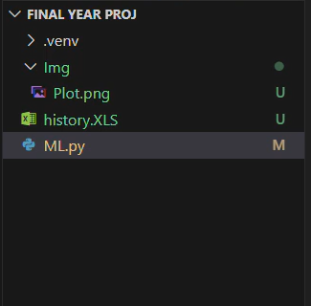

Fig 5.1.1 File Structure

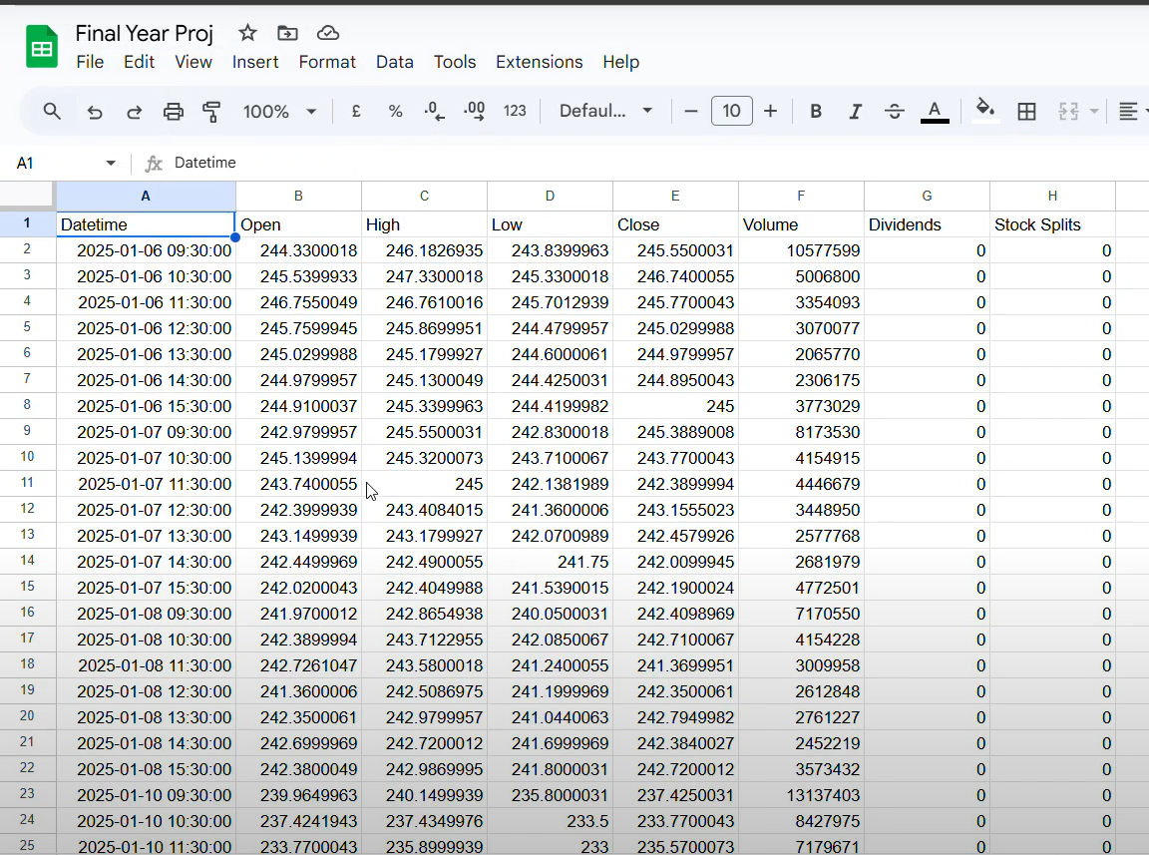

Fig 5.1.2 Data Storage at Google Sheets

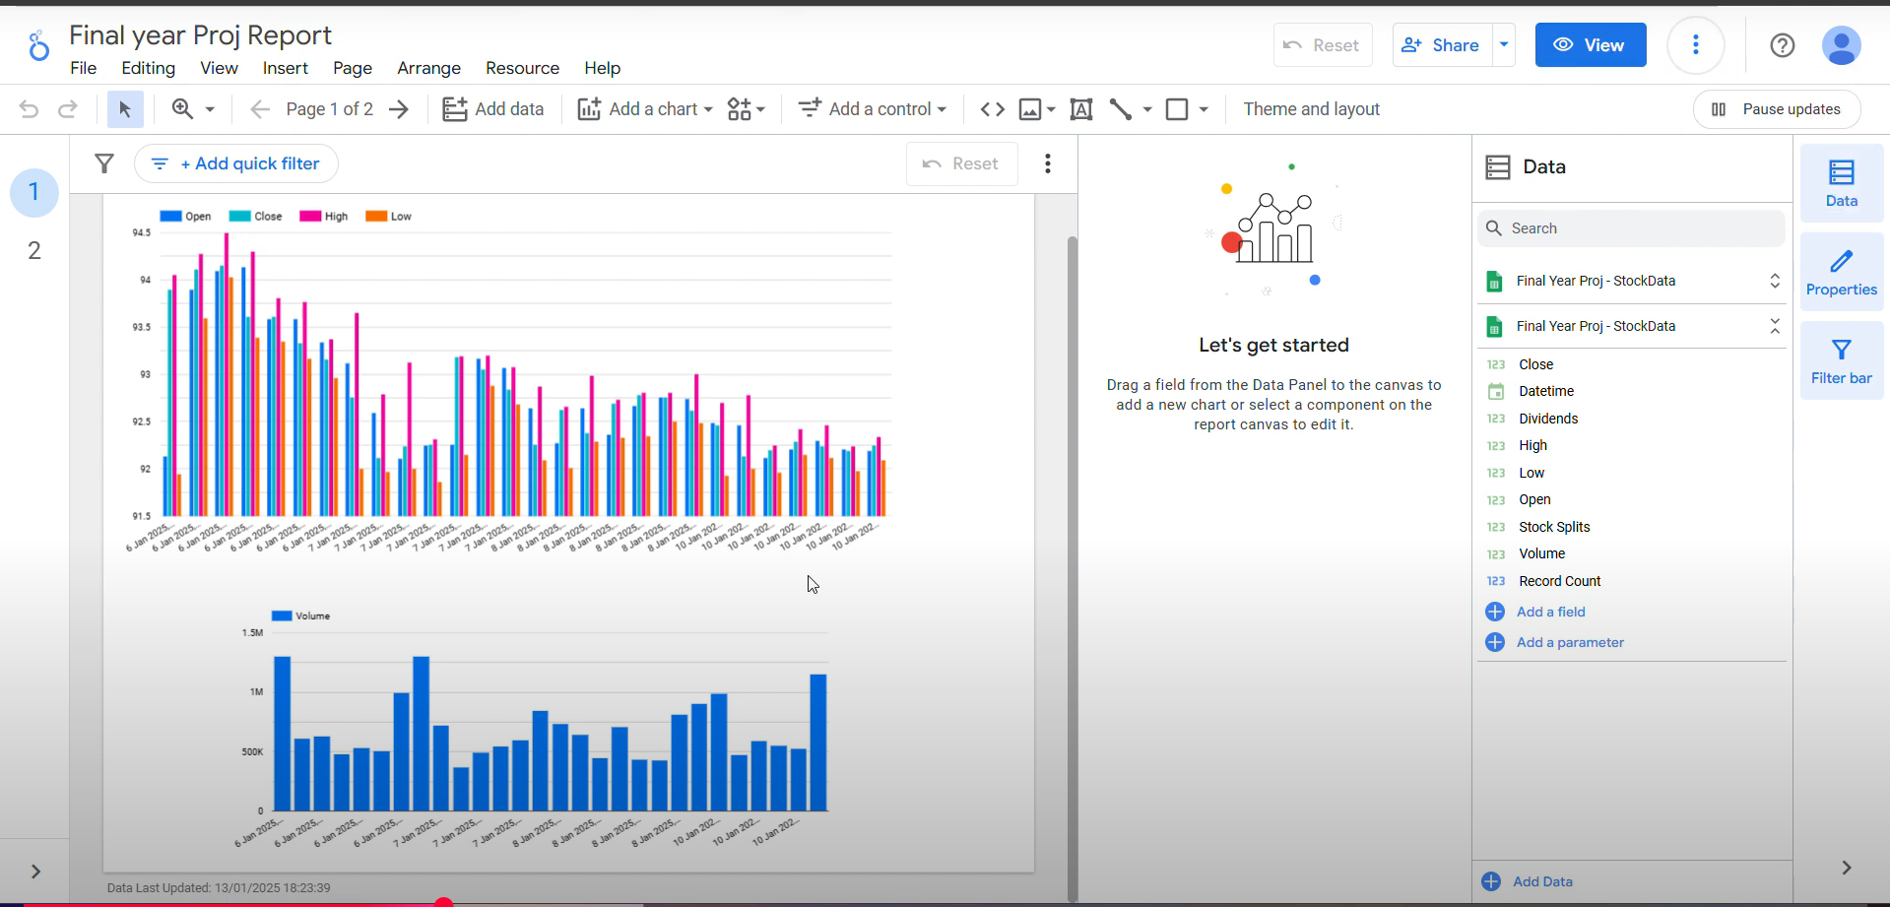

Fig 5.1.3 Data Visualization Using looker studio (Google)

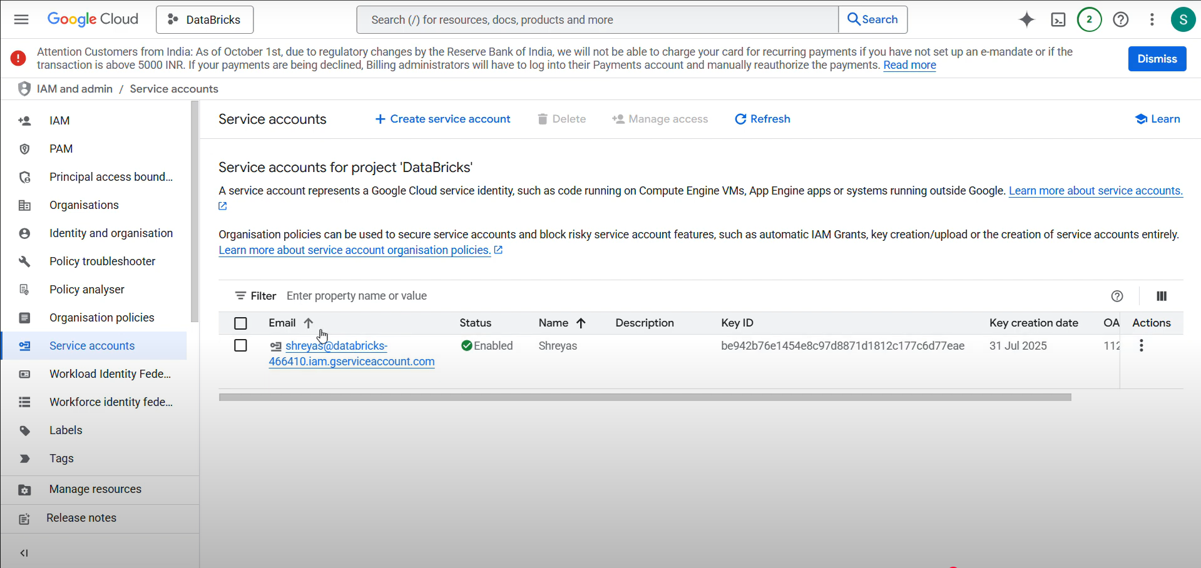

Fig 5.1.4 Service Account Config


Fig 5.1.5 Service Account Granting Access
Sprint 2:

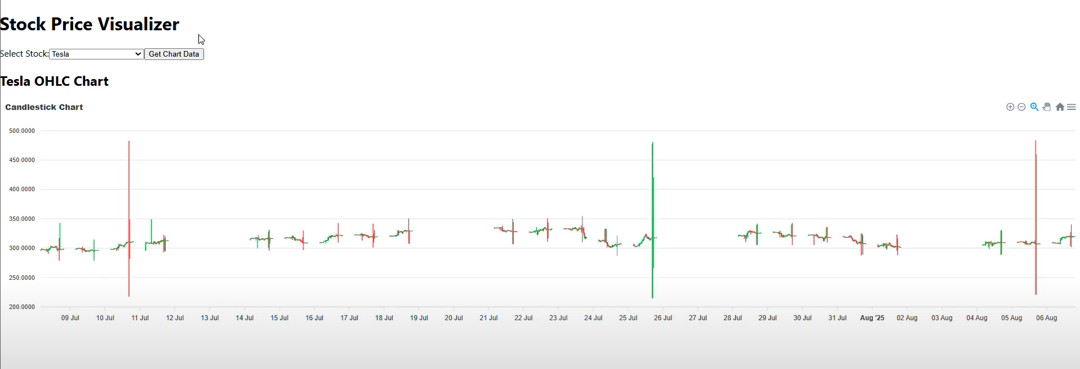
Fig 5.2.1 Data Visualized Using React Library

Sprint 3:

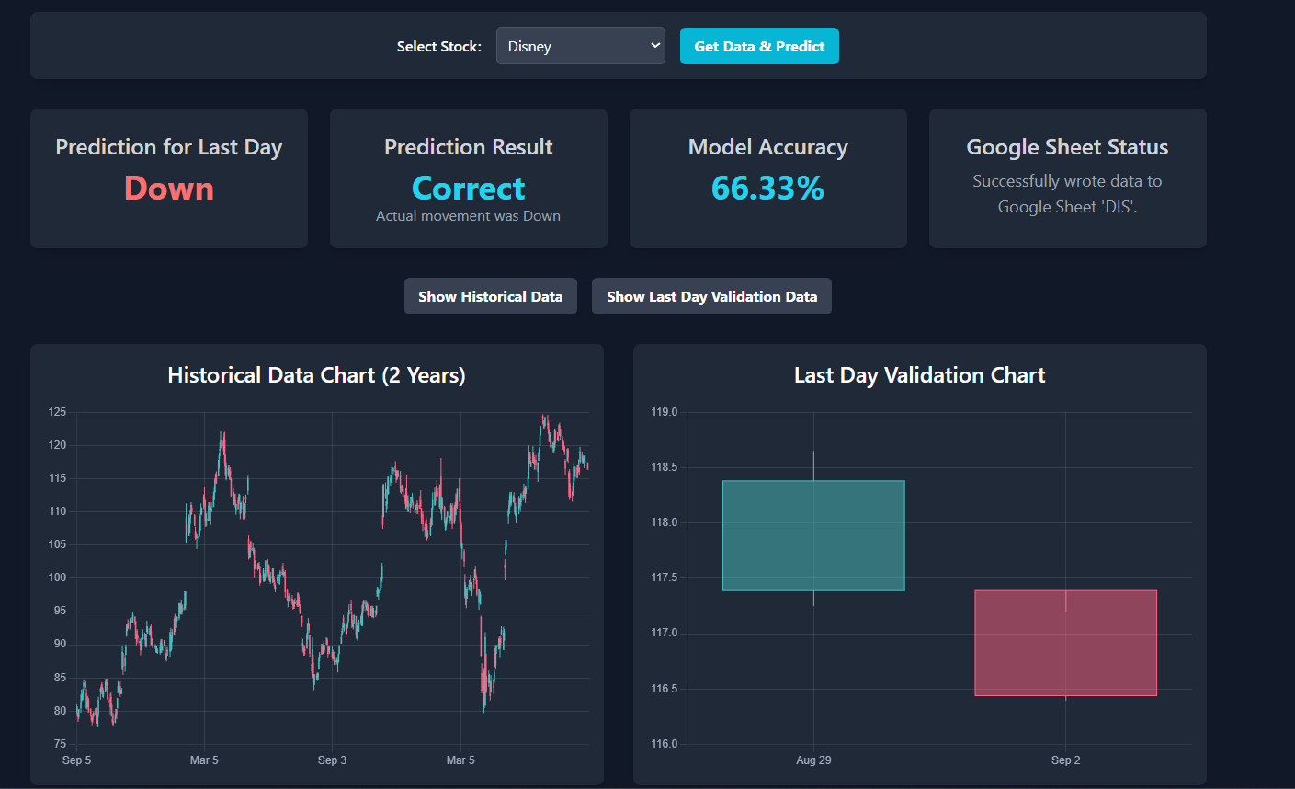
Fig 5.3.1 Model Prediction found Correct

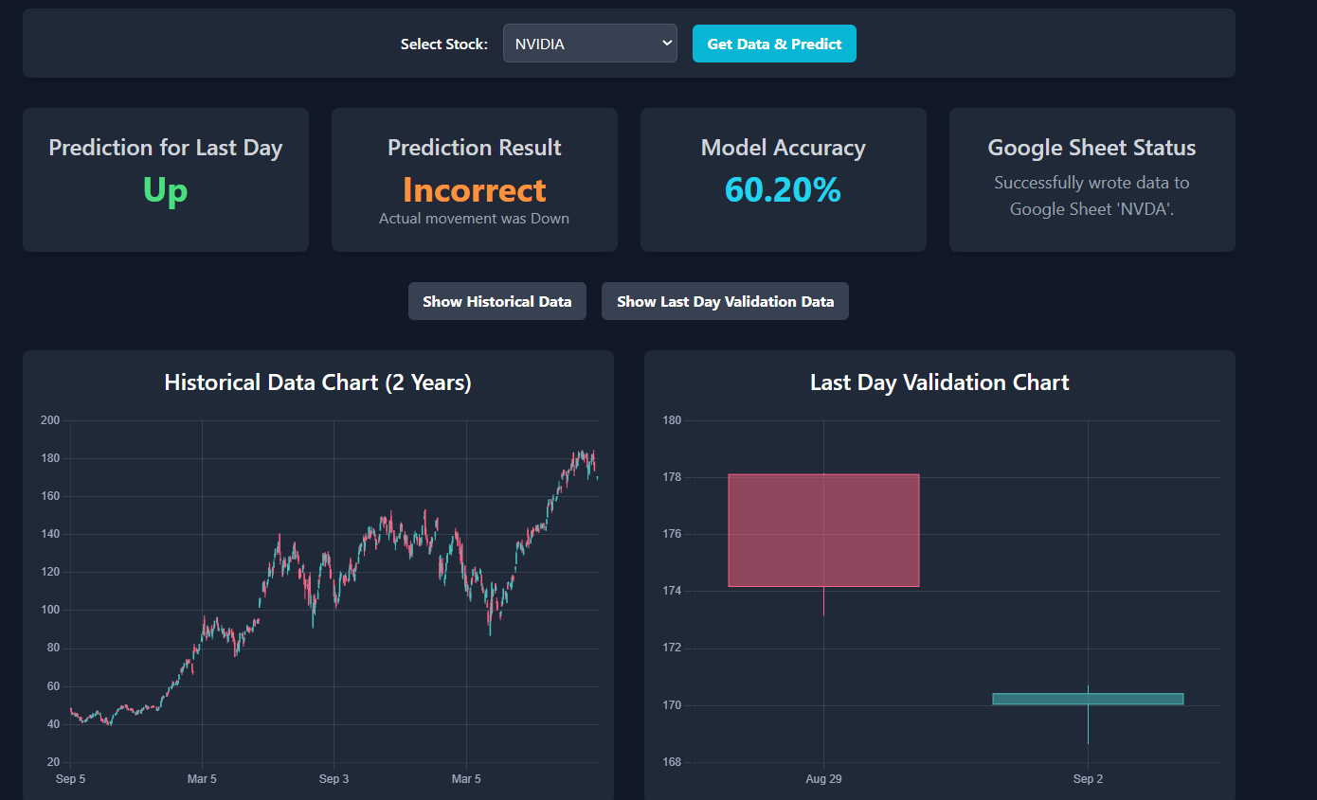

Fig 5.3.2 Model Prediction Found Incorrect

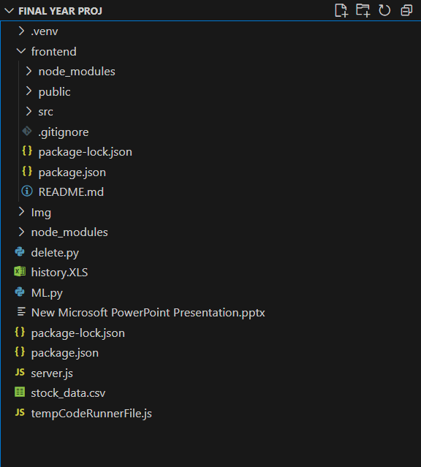

Fig 5.3 File Structure

CHAPTER 6

Summary

The project “Stock Analysis and Prediction using Machine Learning” focuses on predicting short-term stock price movements using historical market data. It utilizes the Yahoo Finance API to collect two years of stock data and performs feature engineering to generate new indicators such as Price Change, 5-day Moving Average, and 10-day Moving Average. A Random Forest Classifier, implemented in Python using Scikit-Learn, is trained on the processed data to identify price movement patterns. The dataset is divided into training, testing, and validation sets, with the final day reserved for validation. The Node.js and Express.js backend connects the machine learning model to a web-based frontend, allowing real-time predictions and visualization. The system demonstrates how integrating machine learning with web technologies can provide valuable insights for investors and researchers, paving the way for more advanced models like LSTM and sentiment-based forecasting in the future.

